**THE ANALYSIS ON THE DISC JOCKEY TRAINING MODEL AT LA STUDIO DJ SCHOOL**

**Joseph Agustinus Friets Sarkol1, Glenie Latuni2, Franklin E. Dumais3**

*Art & Music Study Program, Faculty of Language and Arts*

*Universitas Negeri Manado, Tondano, Indonesia*

*E-mail:*[*josephsarkol@gmail.com*](mailto:josephsarkol@gmail.com)

**Abstract :** This research aims to present a holistic approach in developing DJ skills for students at LA Studio DJ School. The research method applied is a qualitative method rooted in the philosophy of positivism, specifically designed to study the condition of objects scientifically. Researchers, as the key instrument, used purposive and snowball data sampling techniques, with data collection techniques through triangulation. Data analysis was carried out inductively and qualitatively, with an emphasis on meaning rather than generalization. Additionally, LA Studio DJ School also incorporates business elements of the music industry into the curriculum, providing students with an understanding of event management, self-marketing, and building a professional network. With a focus on practical teaching and direct guidance from experienced instructors, this program aims to train high-quality DJs who are ready to compete in the dynamic music industry. Students will develop their own unique style while understanding the essence of the art of DJing and appreciating the diverse forms of expression in the world of music.

**Keywords** : *Disc Jockey (DJ), Training, Music, DJ Technology, LA Studio DJ School.*

**INTRODUCTION**

Based on the definition from the *Kamus Besar Bahasa Indonesia*, Music is the science or art of arranging tones or sounds in sequences, combinations and temporal relationships to produce sound compositions that have unity and continuity. Apart from that, music can also refer to tones or sounds that are arranged to form rhythm, song and harmony, especially involving musical instruments that can produce these sounds.

A disc jockey or DJ, short for disc jockey, is someone who is skilled at selecting and playing sound recordings or previously recorded music. Generally, the media used for recording is disc media or discs, so this profession is known as a disc jockey or disc-jockey. The physical act of a DJ, which involves selecting and playing sound recordings, is known as deejaying or DJing. It covers a wide range of skill levels, from playlist compilation to recording manipulation using techniques such as audio mixing, cueing, phrasing, chopping, scraping, and beat alignment.

In the context of modern music, the Electronic Dance Music (EDM) genre is one of the most popular music genres today. The popularity of EDM, which stretches from adults, teenagers to children, has also had an impact on increasing interest in the disc jockey profession. DJs are considered to be makers of EDM music, and this profession is considered to be more popular than other entertainment professions. Therefore, many new disc jockey schools or training places are established as a place for learning before the individual enters the world of work. The existence of a disc jockey is not limited to nightlife venues, but has also spread to various events in hotels, cafes, lounges and open spaces.

In this era of increasingly sophisticated technological advances, the opportunity to become a DJ is increasingly wide open for anyone. This has led to increased interest in this profession, both among men and women. As demand increases, many disc jockey training places have emerged, such as LA STUDIO DJ SCHOOL, a DJ school located in Manado, North Sulawesi. In Manado City, the profession as a Disc Jockey is now increasingly in demand, especially in the millennial era. Many individuals choose to become a DJ because it is considered an interesting hobby and also a promising profession. With dedication to practice, social skills and creativity, one can become a successful DJ, with an income that is considered quite attractive. Music that is generally played by a DJ, especially what is known as the EDM (Electronic Dance Music) genre, has now become universal and is accepted by various groups of society, including adults, teenagers and children.

Runny Ribka Lumempouw, a Female DJ (FDJ) from Manado, North Sulawesi, revealed the challenges she faces as a female DJ. She stated that being FDJ was considered negative by some people, especially because she was a woman. However, this negative view actually became a challenge and motivation for Runny to prove his abilities. He realizes that being a DJ is not an easy job, especially because it often involves working at night.

Seeing the trend of increasing interest in the DJ profession, especially in Manado City, many young people are interested in becoming a Disc Jockey. This also has an impact on increasing the number of DJ training places or schools in various regions, especially in Manado City. As interest in the disc jockey profession increases, more and more people want to take training at existing DJ schools. Therefore, in this writing, the author aims to examine the disc jockey training model at the LA Studio DJ School. Based on the description above, the author is interested in conducting research to find out the training model practiced in La Studio DJ School.

**RESEARCH METHOD**

The qualitative research approach is a research method that relies on the philosophy of positivism, used to investigate objects under scientific conditions (as opposed to experiments). In this method, the researcher acts as the main instrument, with data sampling carried out purposively and snowballing. Data collection was carried out through triangulation, while data analysis was inductive/qualitative, focusing research results on meaning rather than generalizations.

This research was carried out on Jl. Kasih Valley, Teling Bawah, Wenang District, Manado City, North Sulawesi. This is the home of Mr. Yusdhi Supuh, and here is also a place for DJ training or courses (LA TUDIO DJ).

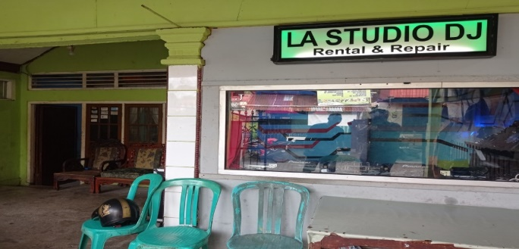**Figure 1.** House and DJ Training Place (Photo/Collection of Joseph AF Sarkol 2022)

In this research, the author made direct observations at the disc jockey training stages at LA STUDIO DJ SCHOOL led by a trainer named Yusdhi. Observations were carried out from the beginning to the end of the training on Friday, August 1 2022. Yusdhi as the trainer provided an introduction to the tools that would be used, explained the function of the buttons on the tools, and then began the training stages. Training begins with a speed hunting phase, namely finding and matching the tempo or BPM (beats per minute). Next, Yusdhi taught beatmatching and mixing techniques, with songs that were generally progressive. The duration of the training usually reaches 3 hours, and during this time, the author observes each stage carried out by the trainer and students in detail. The interviews in this research were conducted directly with DJ Yusdhi at the DJ LA STUDIO DJ SCHOOL studio, located on Jl. Valley of Love, Lower Ear. Apart from that, interviews will also be conducted with family members and students of DJ Yusdhi. The first interview with DJ Yusdhi focused on the material taught in the disc jockey training stages and the obstacles that may be faced during training. This interview process will take place on Friday, 01 August 2022.

The second interview was conducted with DJ Yusdhi's wife, Yathie Khanasabila Gobel, who is 29 years old. This interview aims to get his views on the students taught by Yusdhi. Meanwhile, the third interview was conducted with one of DJ Yusdhi's students, namely Marcelino Bukanaung, aged 24 years. In this session, he was asked about his views on DJ Yusdhi and other DJs working in Manado City.

The interview with DJ Yusdhi's wife and students was conducted on the same date, namely Friday, August 1 2022, at the LA STUDIO DJ SCHOOL studio located at Jl. Valley of Love, Lower Ear. This interview process provides a broader and deeper view regarding the diverse experiences and perspectives within the LA STUDIO DJ SCHOOL environment.

**FINDINGS AND DISCUSSIONS**

LA STUDIO DJ SCHOOL is a DJ training place that provides opportunities for young people who want to learn the art of being a DJ. The name "LA" comes from the suffix of Yusdhi S. Manoarfa's child's middle name, namely Sella. The location is on Jalan Lembah Kasih, Teling Bawah, Wenang District, Manado City, North Sulawesi. Apart from functioning as a training place, LA STUDIO DJ SCHOOL also acts as a home or residence for Mr. Yusdhi Supuh.

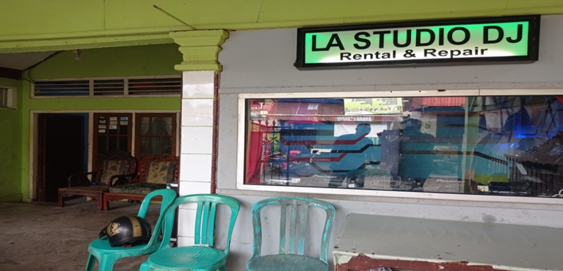

**Figure 2.** Location of LA Studio DJ School (Photo/Collection of Joseph AF Sarkol 2022)

LA STUDIO DJ SCHOOL is a non-formal educational institution founded by Yusdhi Supuh after the COVID-19 pandemic. This place is recognized as a place for training and courses for DJ equipment, as well as a place for those who want to develop their skills as a Disc Jockey (DJ).

Even though it is sometimes referred to as LA STUDIO DJ, the logo actually contains the complete text, namely LA STUDIO DJ SCHOOL. At first, Yusdhi Supu as the owner and trainer at the training center said, "Because he created a Disc Jockey training center, that's why he used the name LA STUDIO DJ SCHOOL."

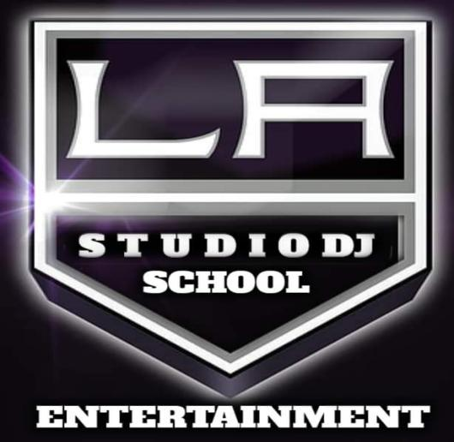

**Figure 3.** LA STUDIO DJ SCHOOL Logo (Photo/Collection of Joseph AF Sarkol 2023)

First of all, Yusdhi Supuh, as the owner and trainer at LA STUDIO DJ SCHOOL, shared, "Actually, the inspiration for the name LA STUDIO DJ SCHOOL came from my child's middle name, namely Sella. Finally, I decided to use the word LA and then add the word STUDIO DJ SCHOOL to fit the concept I want."

Apart from functioning as a Disc Jockey training place, LA STUDIO DJ SCHOOL also provides DJ equipment rental services. Yusdhi Supuh himself is responsible for repairs to DJ equipment carried out at the venue. His abilities are not only limited to being a DJ, but also include the expertise to repair damaged DJ equipment, whether privately owned or from cafes or bars located in Manado City.

**Facilities at LA STUDIO DJ SCHOOL**

LA STUDIO DJ SCHOOL provides learning facilities, namely DJ equipment as shown in the picture below:

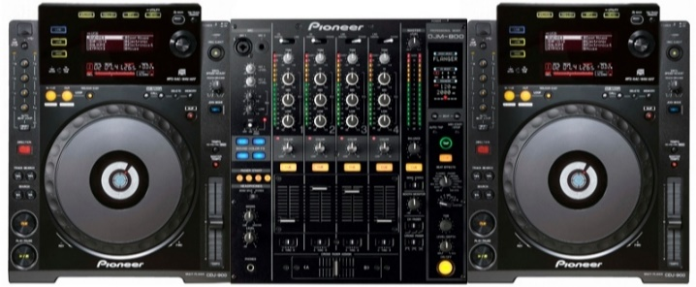**Figure 4.** Pioneer CDJ 900 and DJM 800 DJ equipment (Photo/ Collection of Joseph AF Sarkol 2023)

CDJ-900 is a digital audio player device developed by the leading electronics company, Pioneer. This device is part of a series of CDJ (Compact Disc Jockey) products which are very popular and widely used by professional DJs around the world.

**Learning Model at LA STUDIO DJ SCHOOL**

1. **Beginner:**

* Tool introduction
* How to count the beats in a bar
* Speed ​​hunting
* Beatmaching
* Mixing

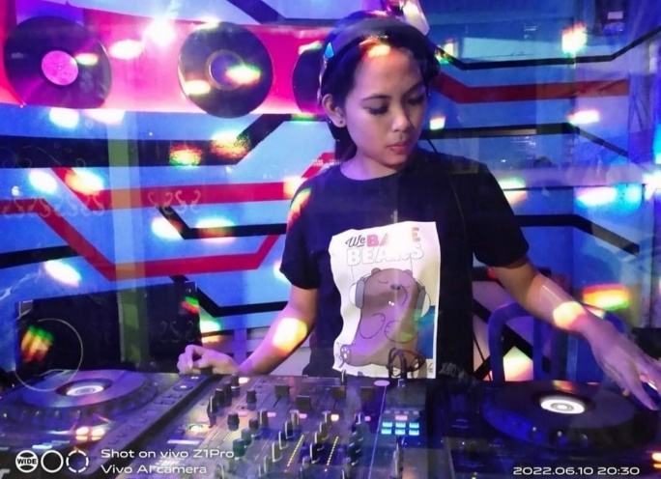

**Figure 5.** Beginner students (Photo/Collection of Joseph AF Sarkol 2023)

DJ School groups students into three stages. The first stage is the beginner stage, where students are new to the equipment and do not yet have knowledge of how to play DJ equipment. At this introductory stage, students are trained to perform speedhunting, beatmatching, and mixing. The duration of this stage varies depending on the student's ability to understand the techniques of playing DJ instruments.

1. **Intermediate:**

* Speed ​​hunting
* Beat maching
* Mixing
* Manual Cueing
* Manual Looping
* Sound Color Fx

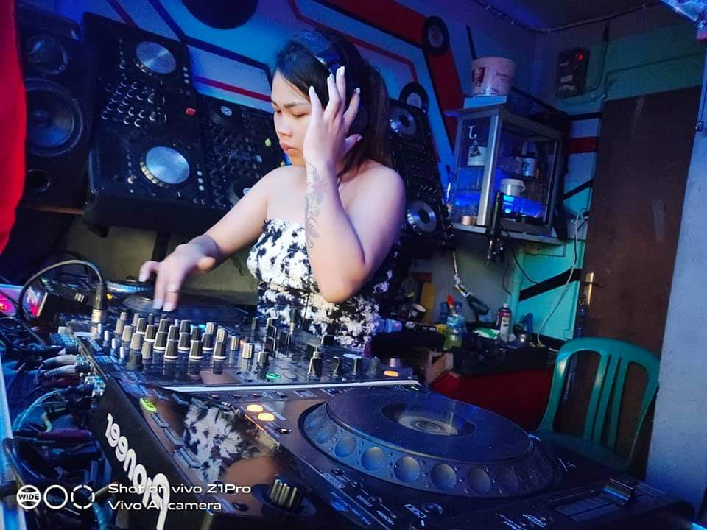

**Figure 6.** Intermediate level student (Photo/Collection of Joseph AF Sarkol 2023)

At the intermediate stage, students generally know and understand DJ equipment in general, although not yet in depth. At this stage, students can already play DJ instruments with a limited level of expertise, so they still need to follow a training program prepared by the teacher. The program covers aspects such as speedhunting, beatmatching, mixing, and soundcolor, which helps students develop their skills in greater depth.

1. **Advanced:**

* Creative Mixing
* Chooping
* Cut
* Scratch

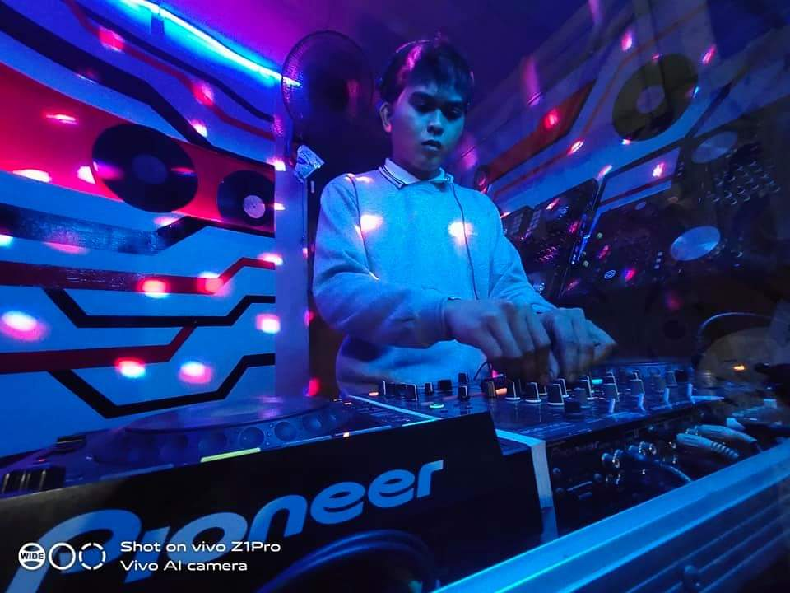

**Figure 7.** Advance level students (Photo/Collection of Joseph AF Sarkol 2023)

At this expert stage, students already know and understand well how to play DJ instruments professionally.

**Program/Curriculum Contents**

The curriculum focuses on the interests and needs of participants with a relatively short training time, usually a few days to a few weeks, and generally less than one year. The learning program structure is flexible with variations in the type and size of activities. The learning process is student-oriented, centered on the community and institutional environment, and related to the lives of students and society. This training or course aims to improve knowledge, skills, hobbies or talents.

The results of this training or course can usually be applied directly in daily life, the work environment, or in society. Supervision is carried out with students by program implementers, and program development is carried out democratically. Like other learning subjects, becoming a professional DJ involves stages of material so that learning DJ skills can be well structured, and each level brings a positive impact to the next stage. For those interested in learning how to become a DJ, understanding the basics is an important first step.

Basic material in DJ school generally includes music or song mixing techniques, known as mixing. Mixing is a fundamental skill for a DJ who is tasked with mixing sound sources into spectacular audio. Basic mixing techniques involve introduction to instruments, beat n club, speed hunting, beat mixing, bar mixing, and creative mixing. At the equipment introduction stage, DJs learn about commonly used DJ equipment, such as turntables or DJ Players and DJ mixers, and understand the function of buttons for maximum use. Next, at the beat n' club stage, the DJ learns the beats of the song's rhythm, which is an important basis for mixing.

In the speed hunting stage, the DJ learns techniques for matching the tempo of two songs being played simultaneously, including how to count the beats manually correctly. The beat mixing stage involves mixing skills correctly, while the bar mixing stage teaches techniques for calculating the second bar of the song to be mixed to ensure the right sound. The final stage involves learning song transitions smoothly to create a pleasant listening experience for the audience. The basic equipment needed by a DJ to carry out his act includes:

* Sound recordings in various mediums (such as vinyl records, CDs, Mp3 files, etc
* Have at least two types of equipment for playing back sound recordings and for the purpose of choosing to play back recordings back and forth (such as record players, compact disc players, mp3 players).
* A sound system (Sound System) to amplify and increase the volume of sound (portable audio system, radio wave broadcaster)

Important supporting equipment involves a mixer that is used to synchronize two or more sound playing devices. Microphones are used to amplify the human voice, while headphones are needed for listening while playing other sound players, so that they can still control the sound heard by the listener. Additional equipment such as samplers, drum machines, effects processors, slipmats, and computerized performance systems may also be included.

A DJ has various techniques for manipulating previously recorded music. These techniques involve audio mixing, cueing, slip-cueing, phrasing, cutting music, beat juggling, scratching, beatmatching, needle drops, phase shifting ( phase shifting), and more.

At LA Studio DJ, students will be taught the basics of DJ Mixing techniques and how to become a Professional DJ. This course focuses on international Pioneer CD Player standards.

**Constraint**

Obstacles in the training process refer to all factors that hinder the smooth absorption of knowledge, often causing realization not to be in accordance with the initial plan. These obstacles can come from various sources, including organizers, instructors, or participants. Some obstacles in the training process include:

1. **Training planning stage**

Training planning is prepared based on the results of previous training evaluations. One of the limitations that arises is the limited information related to evaluation results, such as identifying presenters who are considered effective in presenting material and providing practical examples to participants, or determining training materials that need to be updated. Limited detailed information often becomes an obstacle in planning or selecting an appropriate training program, or even in starting a new training program.

1. **Training briefing stage**

In training briefings there are at least two obstacles that are usually found, namely:

* Delay in Comprehension. The training process runs according to the planned schedule. In its implementation, some participants may experience difficulty in understanding the material, so that they lag behind other participants. Participants who experience delays in understanding or absorbing knowledge during training may face difficulties in improving their skills.
* Resignation. Apart from that, there is also the possibility of participant withdrawal during the training process. Some participants may choose to withdraw before the training is completed or not proceed to the next stage. The reasons for withdrawal can vary, ranging from incompatibility with interests and talents to other personal reasons that make participants decide not to continue training.

**CONCLUSION**

The Disc Jockey training model follows the same principles as other learning subjects, where becoming a professional DJ requires completing stages of material in a structured manner. The importance of setting these levels is to ensure that DJ skills training takes place in an organized manner, with each level providing a positive impact that prepares participants for the next stages. For those interested in learning how to become a DJ, the essential first step is to understand all the basic material first.

**REFERENCES**

Chemam, M. (2021). From Sound Systems to Disc Jockeys, from Local Bands to Major Success: On Bristol’s Crucial Role in Integrating Reggae and Jamaican Music in British Culture. *Narratives from Beyond the UK Reggae Bassline: The System is Sound*, 233-247.

Dessler, G. (1997). *Human Resource Management*, ed. ke-7. (B. Benjamin, Terj.). Prentice Hall, Inc., New Jersey.

Gravilla, Y. L., & Warouw, D. M. D. (2022). Pola Komunikasi Antarpribadi Komunitas K-Pop Dance Cover Manado. *ACTA DIURNA KOMUNIKASI*, *4*(4).

Hassan, O. M., & El-Taher, S. M. (2020). Cardiovascular Risk and Hearing Threshold Levels on Disc Jockey Workers. *Egyptian Journal of Occupational Medicine*, *44*(2), 633-648.

Imron, A. (2007). *Belajar dan Pembelajaran.* Jakarta: Pustaka Jaya.

Lisnawan, H. B. (2018). *Pemanfaatan Soundcloud Sebagai Media Promosi Oleh Disc Jockey (Suatu Studi Deskriptif tentang Fenomena Soundcloud Dikalangan Musisi Disc Jockey Yogyakarta).* Skrispi, Universitas Islam Indonesia. Accessed from <https://dspace.uii.ac.id/handle/123456789/8286>

Meyunis, M., & Rahayunianto, A. (2021). Strategi Komunikasi United Dance Works (Udw) Dancers Dalam Membangun Reputasi. *The Source: Jurnal Ilmu Komunikasi*, *3*(2), 46-62.

Mulyana, D. (2001). *Metode Penelitian Kualitatif.* Bandung: Remaja Rosdakarya.

Noe, R., Hollenbeck, J., Gerhart, B., Wright, P. (2003). *Human Resource Management, International Edition*. New York: The McGraw-hill Companies, Inc.

Pandya, N. D., Shah, C. J., Mehta, H. B., Sharma, S., & Kota, K. (2021). A study of occupational noise-induced hearing loss using pure tone audiometry in disc jockeys of Bhavnagar. *National Journal of Physiology, Pharmacy and Pharmacology*, *11*(9), 940-943.

Rachmawati, Y., & Kurniati, E. (2005). *Strategi Pengembangan Kreativitas pada Anak Usia Taman Kanak-kanak.* Jakarta: Depdikdub.

Rosari, D. C. (2014). *Pusat pelatihan disc jockey dan modern dance di Yogyakarta.* Skripsi, Universitas Atma Jaya. Accessed from <https://core.ac.uk/download/pdf/80819862.pdf>

Samsul, R & Daryana, H. A. (2022) TEKNIK KEGIATAN BELAJAR TUTORIAL PADA MATERI SPEED HUNTING DI BANDUNG DISC JOCKEY SCHOOL (BDJS). Skripsi, Universitas Pasundan. Accessed from <http://repository.unpas.ac.id/id/eprint/55672>

Sari, E. B., & Hartini, H. (2019). Studi Di Sekolah Dancer Yudha Management Di Kota Kendari. *KABANTI: Jurnal Kerabat Antropologi*, *3*(1), 53-60.

Slameto. (2010). *Belajar dan Faktor-Faktor yang Mempengaruhi*. Jakarta: Rineka Cipta.

Sugiono. (2010). *Metode Penelitian Kuantitatif, Kualitatif R&D*. Bandung: Alfabeta Publishers.

Syabanayretin, M. F. R. R., & Suherman, M. (2022, January). Studi Fenomenologi Komunikasi Sosial Pengamen di Kota Bandung. In *Bandung Conference Series: Public Relations* (Vol. 2, No. 1, pp. 185-189).

Wadey, R., & Griffiths, L. (2019). Reactions to return to the decks: Melissa Scruton, a professional disc jockey. In *The Psychology of Sport and Performance Injury* (pp. 130-147). Routledge.